**Software Engineering Project**

**Hotel Management System**

**Steps to run the project:**

1. First download and install XAMPP web sever from the given link <https://www.apachefriends.org/index.html>
2. Run the XAMPP control panel and start Apache and MySQL module.

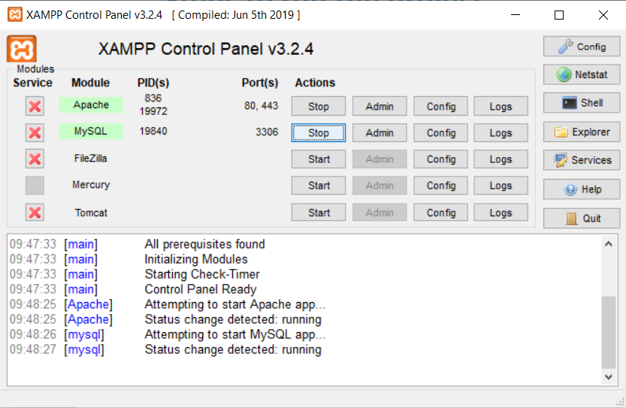

1. Extract the HMS file and then move the extracted folder to htdocs folder present in C:\xampp.
2. Now open <http://localhost/phpmyadmin/> in your web browser.

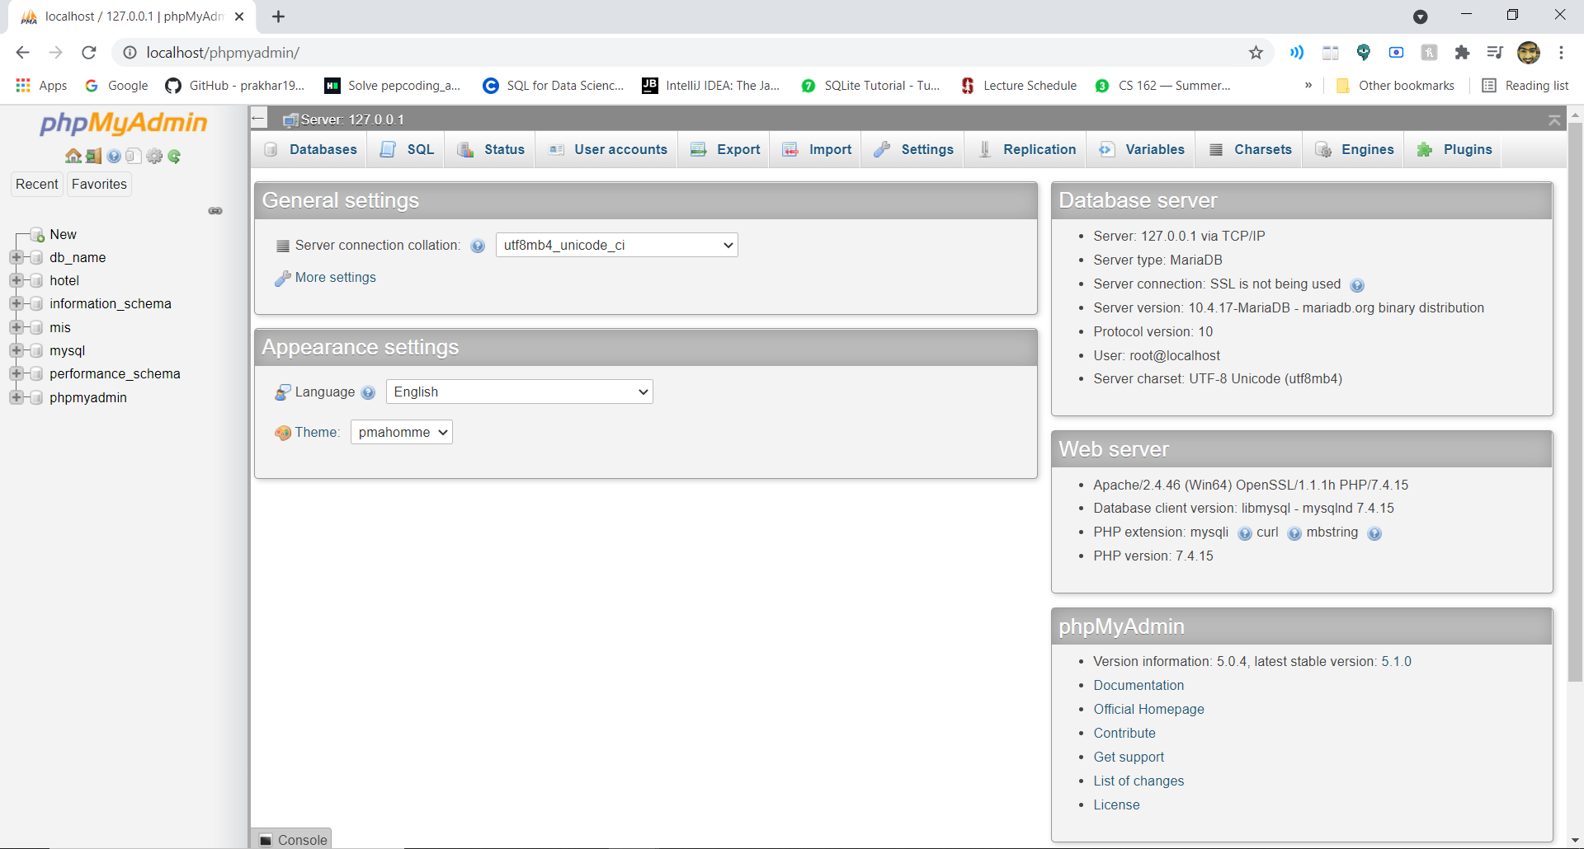

1. Create a new database by the name hotel in phpMyAdmin and then export the hotel.sql file present in the database folder in the extracted folder.

**Note:** The name of database must be hotel or else the project won’t run.

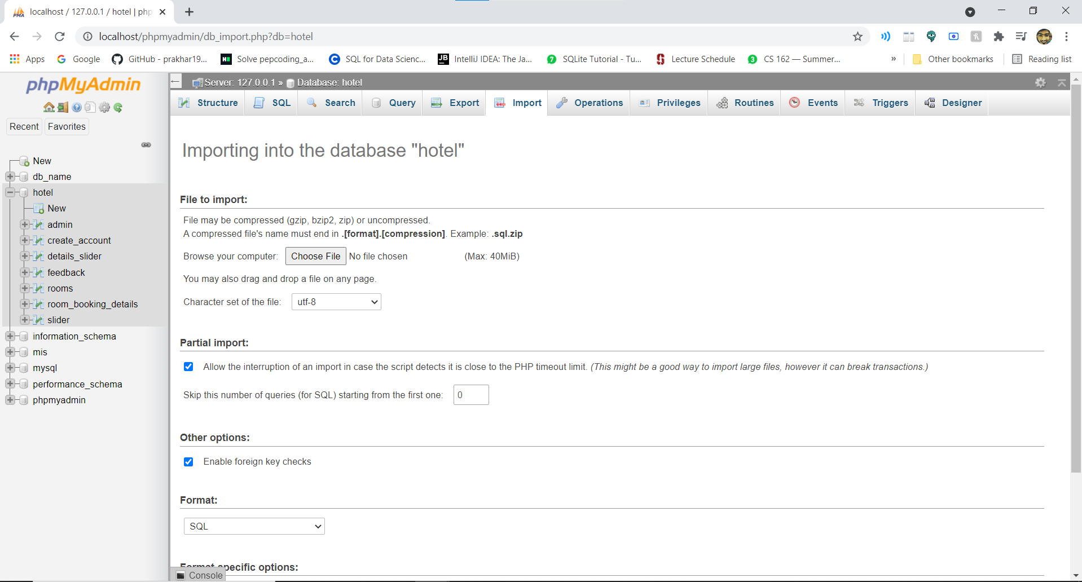

1. Now open <http://localhost/HMS/> in your browser and the project is up and running.

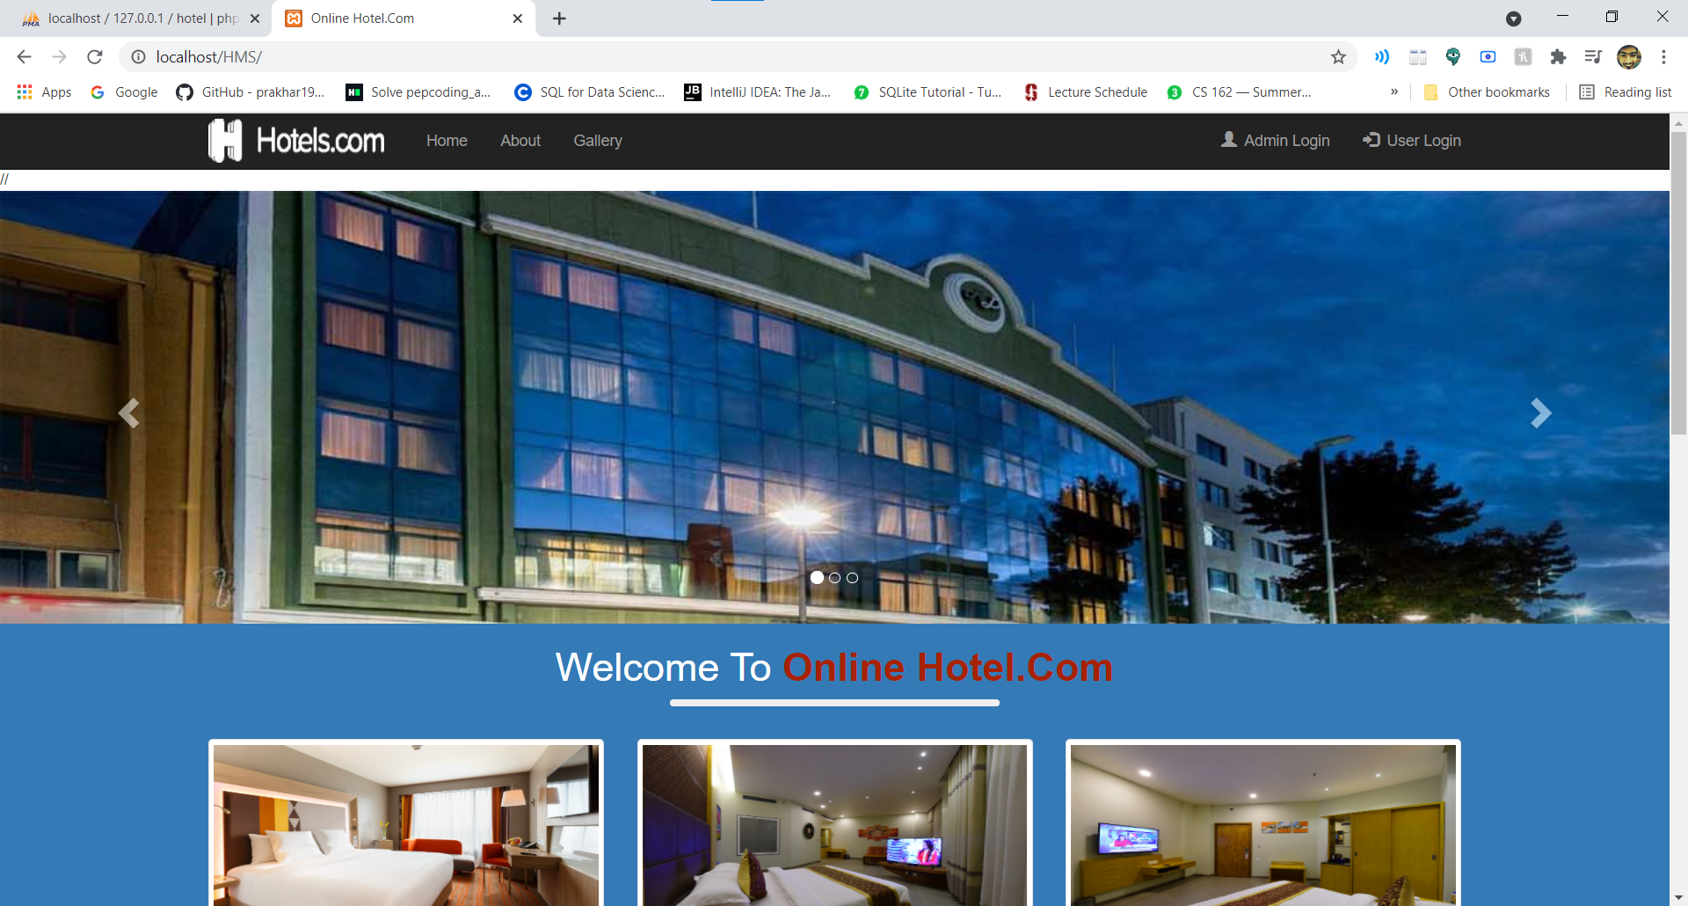

**Login Credentials**

**e-mail password**

**Admin** [admin@gamil.com](mailto:admin@gamil.com) 12345

**User** [jai@gmail.com](mailto:jai@gmail.com) jai

**User** [garima@gamil.com](mailto:garima@gamil.com) garima

**By:**

Jaivardhan Singh Chaudhary (24)

Garima Singh (20)